20250112 UMRLAC review FERC projects
[presented at January 12, l2026 UMRLAC meeting.]
Lakeport p-6440
Penacook Lower Falls p-3342
Penacook Upper Falls p-6689
Rolfe Canal p-3240
eLibrary | General Search Results (ferc.gov)

Lakeport p-6440
For January meeting
12/12/25 - Lakeport Hydroelectric One, LLC submits non-public updates to the Emergency Notification Flowchart and distribution list under a cover letter.

12/23/25 - Lakeport Hydroelectric One, LLC submits request for the continuation of the exemption from filing an Emergency Action Plan

For December meeting
10/22/2025 – Lakeport Hydroelectric One, requests an extension until 09/30/2028 to complete the first Part 12D Periodic Inspection since the State and LHO have yet to establish responsibilities under the shared relicensing.

10/23/25 – FERC letter to LHO saying that LHO has satisfactorily addressed several comments and their plan for addressing the others is satisfactory. LHO is to continue the recruitment process for the open positions and provide a staffing update with their annual review and update of Owner’s Dam Safety Program and any necessary update to your ODSP by December 31, 2025.

10/31/25 – FERC letter accepting their proposed extension (dated October 22, 2025) to September 30, 2028.

11/3/25 – Letter to FERC documenting that Jody Smet and Melissa Rondou are responsible for the project.

11/6/2025 – Dam Safety Inspection Report for 6/5/2024 to 5/13/2025 cover document and non-public report.

The approximate location of the project can be viewed in Google Maps: https:// www.google.com/maps/@43.575105300000004,-71.45826273045957,14z
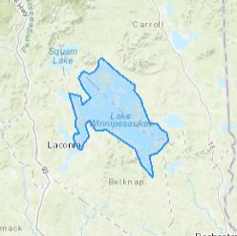

The location of the project can be viewed in Google Maps: 43°32'54.7"N 71°27'54.1"W - Google Maps

LAKE WINNIPESAUKEE LAKE LEVEL DATA GRAPH (nh.gov)
Lake level has been below average since the beginning of July. Mid September through October lake level at or near lowest historical levels. Lake level has risen slightly in December, but was still below the winter drawdown level until the end of December. (There is no 2026 graph yet.)
Dam Bureau decreased outflow at the dam to the minimum release rate (250 cfs) beginning July 15. They maintained the minimum discharge of 250 cfs through August and September (which was greater than inflow until a brief increase in inflow at the end of September). Dam Bureau went to an emergency reduced release of 50 cfs starting 8am October 13, 2025 which has continued through this first week of January.

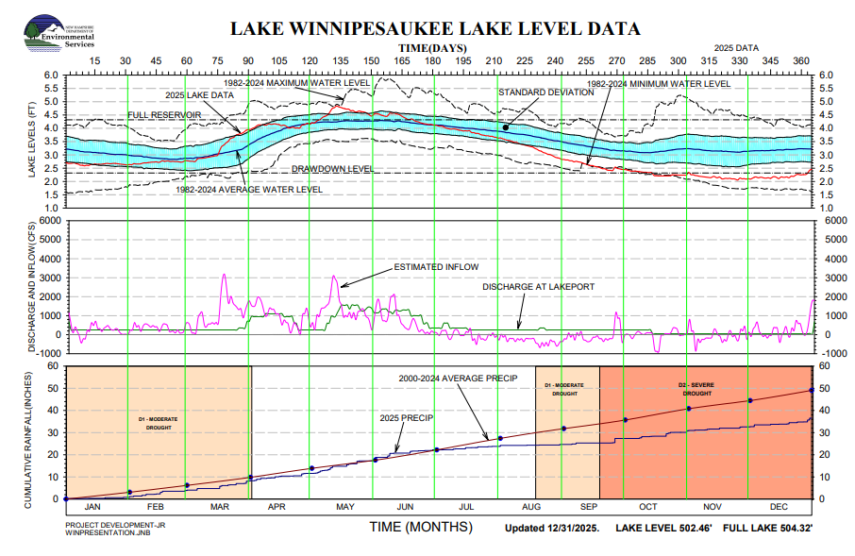

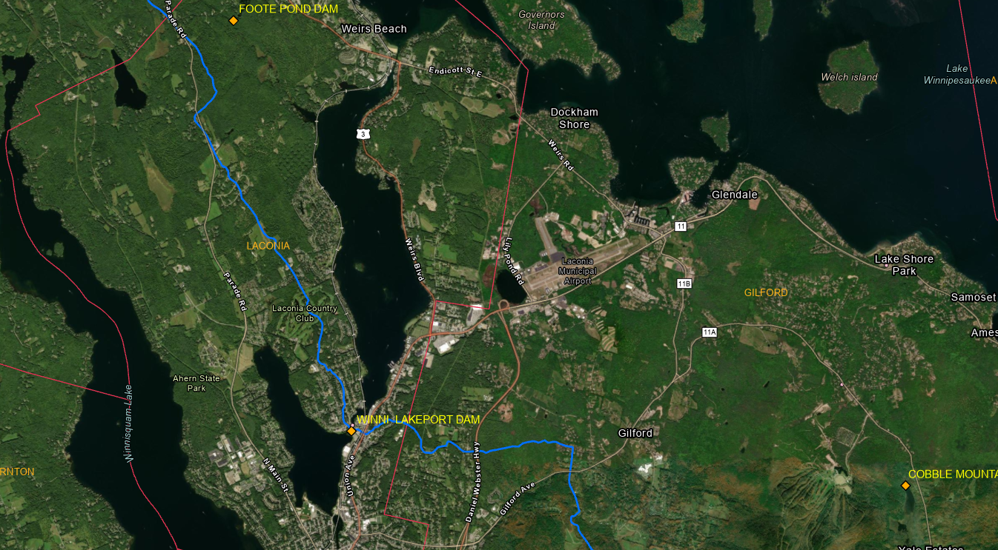
Winni Lakeport Dam location and environs

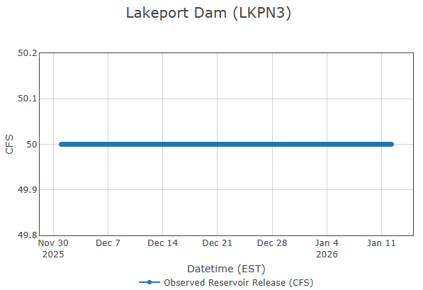
From Dam Bureau’s Lakeport Dam (LKPN3)
Data source: Real-Time Data & Information for Watersheds in New Hampshire (rtiamanzi.org)

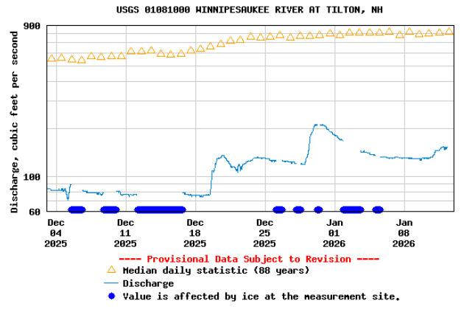
Winnipesaukee River flow data are at USGS Current Conditions for USGS 01081000 WINNIPESAUKEE RIVER AT TILTON, NH. The location of the Winnipesaukee gage can be seen at 43°26'30.3"N 71°35'18.1"W - Google Maps.

Penacook Upper Falls p-6689
eLibrary | General Search Results (ferc.gov) W I @ des Recon
For January meeting
12/15/2025 – FERC sends letter to Essex Hydro Associates stating they have adequately responded to FERC’s letters regarding the dam stability analysis and no further action is required.

1/5/26 - Essex Hydro Associates sent FERC a letter saying no changes in property or circumstances affecting their hazard classifications have taken place upstream or downstream of the three Penacook projects.

For December meeting
10/16/2025 – FERC Environmental Assessment document – pp. 119 - selected the staff alternative with the measures proposed by Briar Hydro or the agencies and applicable to each of the projects.
Operation
• Continue to operate the project in a run-of-river mode where outflow approximates inflow. Document Accession #: 20251016-3019 Filed Date: 10/16/2025 P-6689-018 41
• After planned and unplanned drawdowns, release 90% of the inflow through the turbine while refilling the impoundments with the remaining flow.
• Continue to implement nighttime turbine shutdowns (from 7 pm to 5 am) from August 15 through November 15, or beginning when the Contoocook River reaches a water temperature of 50o F, whichever comes first, until downstream fish passage is provided at the PLF Project.
• Install 0.75-inch seasonal intake screens and operate the existing downstream bypass from August 15 through November 15 to prevent entrainment of juvenile alosines and outmigrating adult eels. Operate the project such that the average intake approach velocity does not exceed 2 feet per second (fps), nightly (7 pm to 5 am) when the new intake screens are installed to protect eels.
• Develop a Fishway Operations and Maintenance Plan and Fishway Operations and Maintenance Report.
• Develop an operation compliance monitoring plan that specifies the methods that would be used to monitor and document compliance with project operation.
• Install 0.75-inch seasonal intake screens from May 15 to November 15 (instead of May 15 through July 15 and August 15 through November 15) to protect out-migrating alosines and eels.
• Develop a plan to monitor the effectiveness of the downstream fishway and upstream eel lift.
• Operate the existing eel lift for upstream eel passage from May 1 through October 15 (instead of May 15 through September 15).
• Release a 5-cfs passage attraction flow at the existing eel lift to provide upstream eel passage at the project.
• Avoid the removal and trimming of trees from April 1 through October 31 to protect NLEB and tri-colored bat.
Finding of No Significant Impact
If the Project is relicensed as proposed, with the additional staff-recommended measures, and modifications, the project would continue to operate as it does today, while providing protection and enhancements for fish and wildlife resources, and cultural resources. Based on our independent analysis, issuance of a new license for the PUF Project, as proposed with the staff-recommended measures and modifications, would not constitute a major federal action significantly affecting the quality of the human environment.

10/16/2025 – FERC letter to Dept of the Interior asking for concurrence that the Commission staff’s recommended measures, is “not likely to adversely affect” the northern long-eared bat, and that relicensing the project, with Commission staff’s recommended measures, would not be sufficient to preclude both the survival and recovery of (i.e., jeopardize) the tricolored bat and the monarch butterfly.

10/16/2025 – Noticing the availability of the EA.

10/16/2025 – FERC letter to NH F&G requesting response to preliminary determination not to adopt three of their recommendations.

• Conduct a study to determine if the attraction flows for the new downstream fish passage operation affects the attraction flows for the upstream eel lift during periods when the upstream eel passage season overlaps with the downstream passage season for shad, river herring, and eels.
• Extend the downstream passage season for eels to end November 30 (rather than November 15) and discuss efficacy of a temperature trigger in consultation with the Merrimack River Technical Committee.
• Monitor juvenile clupeid mortality below the project and work with the Merrimack River Technical Committee to develop additional protection measures if needed.
FERC wants to know if F&G accepts, or if not, if there are other measures, and if there is more evidence to support the F&G recommendations.

10/31/2025 - Essex Hydro Associates, L.L.C. et al. submit Annual Kilowatt-hour Generating Report for the period of 10/01/2024 to 09/30/2025. Cover letter with non-public data.

11/3/2025 – NHDES submits Clean Water Act Section 401 Water Quality Certifications covering upper, lower and Rolfe Canal - largely requiring reporting and access to data, access for inspections, with run of river, but a 5 cfs minimum discharge. The conditions describe drawdown and refill procedures (releasing 90% of the inflow).

11/12/2025 - New Hampshire Fish and Game Department comments on the Environmental Assessment taking issue with several assumptions made in the EA concerning maintaining run of river versus operational issues; the schedule for d/s fishway operations; the effectiveness of the fish racks relying on models; questioning the effectiveness of racks for exclusion of eels; the lack of fish count requirements.

11/14/2025 - Briar Hydro Associates, LP submits response re the Environmental Assessment making clarifications that seem to refute some of FERC’s suppositions.

11/24/2025 - Briar Hydro Associates, LP submits response to New Hampshire Fish and Game Department's 11/12/2025 comments to FERC agreeing with FERC’s conclusions and commenting on why they agree.

The location of the project can be seen at: 43°16'58.5"N 71°36'04.5"W - Google Maps

Penacook Lower Falls p-3342
eLibrary | General Search Results (ferc.gov)
For January meeting
12/15/2025 - Same letter to Essex as for Upper Falls stating they have adequately responded to FERC’s letters regarding the dam stability analysis and no further action is required.

1/5/26 – Same letter from Essex Hydro Associates to FERC saying no changes in property or circumstances affecting their hazard classifications have taken place upstream or downstream of the three Penacook projects.

For December meeting
10/29/25 - New Hampshire Fish and Game Department re FERC's Environmental Assessment – see upper falls 11/12 entry.

10/29/2025 – Briar Hydro Associates submits comments on FERC's Environmental Assessment

10/30/2025 – Briar Hydro Associates submits response to NH F&G’s 10/29 comments on FERC's Environmental Assessment.

10/31/2025 - Essex Hydro Associates, L.L.C. et al. submit Annual Kilowatt-hour Generating Report for the period of 10/01/2024 to 09/30/2025. Cover letter and non-public data.

11/3/2025 - NHDES submits Clean Water Act Section 401 Water Quality Certifications covering upper, lower and Rolfe Canal - largely requiring reporting and access to data, access for inspections, with run of river, but a 5 cfs minimum discharge. The conditions describe drawdown and refill procedures (releasing 90% of the inflow).

The location of the project can be viewed in Google Maps at: https://www.google.com/maps/place/43%C2%B017'08.4%22N+71%C2%B035'42.1%22W/@43.285674,-71.5968567,686m/data=!3m2!1e3!4b1!4m4!3m3!8m2!3d43.285674!4d-71.595036?entry=ttu

Rolfe Canal p-3240
eLibrary | General Search Results (ferc.gov)
For January meeting
12/15/2025 - Same letter to Essex as for Upper and Lower Falls stating they have adequately responded to FERC’s letters regarding the dam stability analysis and no further action is required.

1/5/26 – Briar Hydro Associates sent a letter to FERC re: clarification of certain water quality certificate conditions as a result of preliminary notice of appeal and discussions with NH DES for Rolfe Canal P-3240-040. BHA filed a preliminary notice of appeal concerning the issued a water quality certificate issued October 31, 2025 by NHDES. Briar Hydro and NHDES agreed that the primary concerns regarding conditions E-11 and E-12 could be largely addressed by a letter of clarification. Briar Hydro drafted and submitted the letter to NH DES on December 22 and NH DES staff responded that they agreed with the letter on December 29.
- When a new FERC license is issued and the water quality certificate becomes effective, dissolved oxygen monitoring will only be required at the penstock intake in summer months (May through September). The dissolved oxygen monitoring described above will be done for a minimum of one year but it may be required to be repeated should monitoring results indicate a violation. [I don’t recommend any LAC action be taken for this.]
- It was acknowledged that additional bypass flows at the penstock intake required for downstream fish passage may be sufficient remedial measure to address concerns regarding a decreasing trend in dissolved oxygen at the penstock intake during periods of turbine shutdown. This will not be implemented until downstream fish passage facilities are required. [I don’t recommend any LAC action be taken for this.]
- Clarification of the power transmission line description. [I don’t recommend any LAC action be taken for this.]
BHA requested a response by the end of the year.

1/5/26 – Same letter from Essex Hydro Associates to FERC saying no changes in property or circumstances affecting their hazard classifications have taken place upstream or downstream of the three Penacook projects.

For December meeting
10/8/2025 - Briar Hydro Associates, LP submits response to the New Hampshire Fish and Game Department's 10/02/2025 comments re Environmental Assessment. Same as above.

10/31/25 - Essex Hydro Associates, L.L.C. et al. submit Annual Kilowatt-hour Generating Report for the period of 10/01/2024 to 09/30/2025. Cover letter and non-public data.

11/3/2025 - NHDES submits Clean Water Act Section 401 Water Quality Certifications covering upper, lower and Rolfe Canal – see previous.

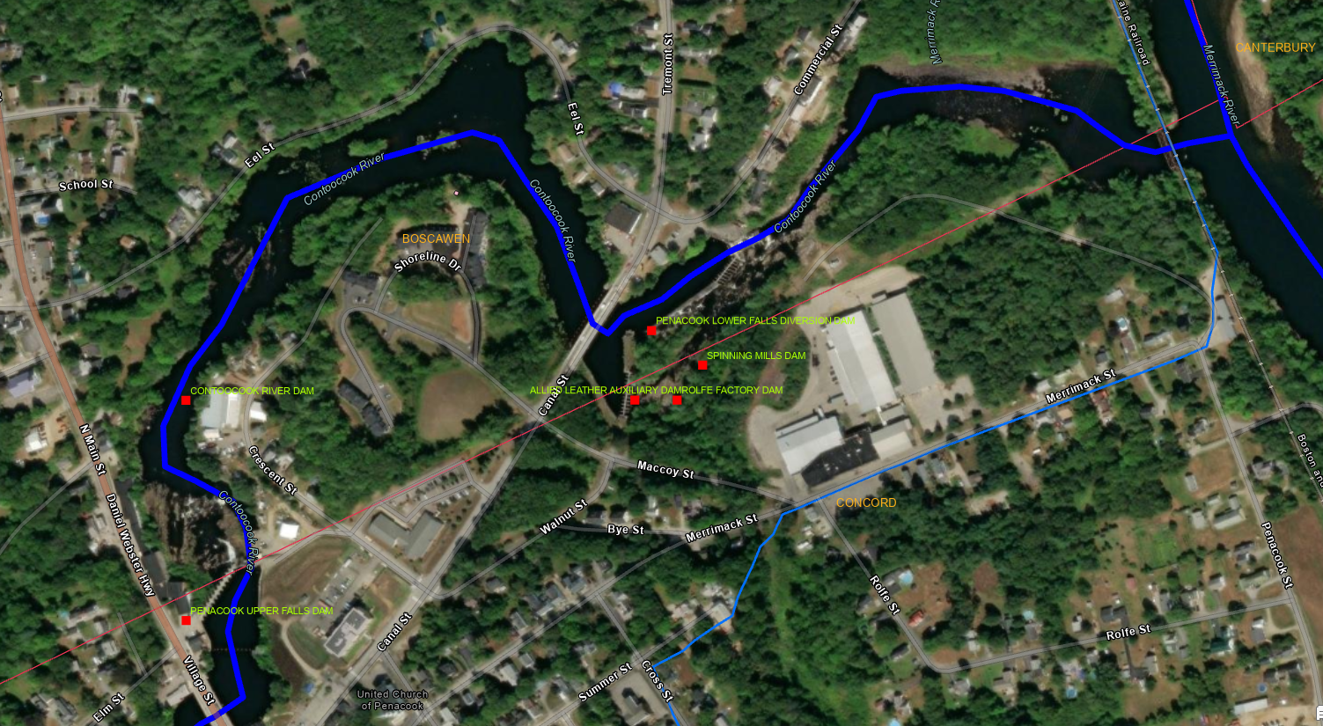
Penacook upper and lower Falls Dams and Rolfe Dam on the Contoocook River.

